Practical – 7

## Aim : Create a web page using the concept of cascading style sheets in ASP.NET.

CSSDemo.aspx

<%@ Page Language="vb" AutoEventWireup="false" CodeBehind="CSSDemo.aspx.vb" Inherits="Practical_07.WebForm1" %>

<!DOCTYPE html PUBLIC "-//W3C//DTD XHTML 1.0 Transitional//EN" "http://www.w3.org/TR/xhtml1/DTD/xhtml1-transitional.dtd">

<html xmlns="http://www.w3.org/1999/xhtml">

<head runat="server">

<title>CSS Declaration Demo</title>

<link rel="Stylesheet" type="text/css" href="CSSDemo.css" />

<style type="text/css">

h1

{

color:Lime;

}

</style>

</head>

<body>

<form id="form1" runat="server">

<div>

<input type="text" style="background-color:Purple;border:2px solid white;" placeholder="inline CSS" />

<h1> Internal CSS </h1>

</div>

</form>

</body>

</html>

CSSDemo.css

body

{

background-color: Gray;

}

div

{

background-color: Red;

}

Output :

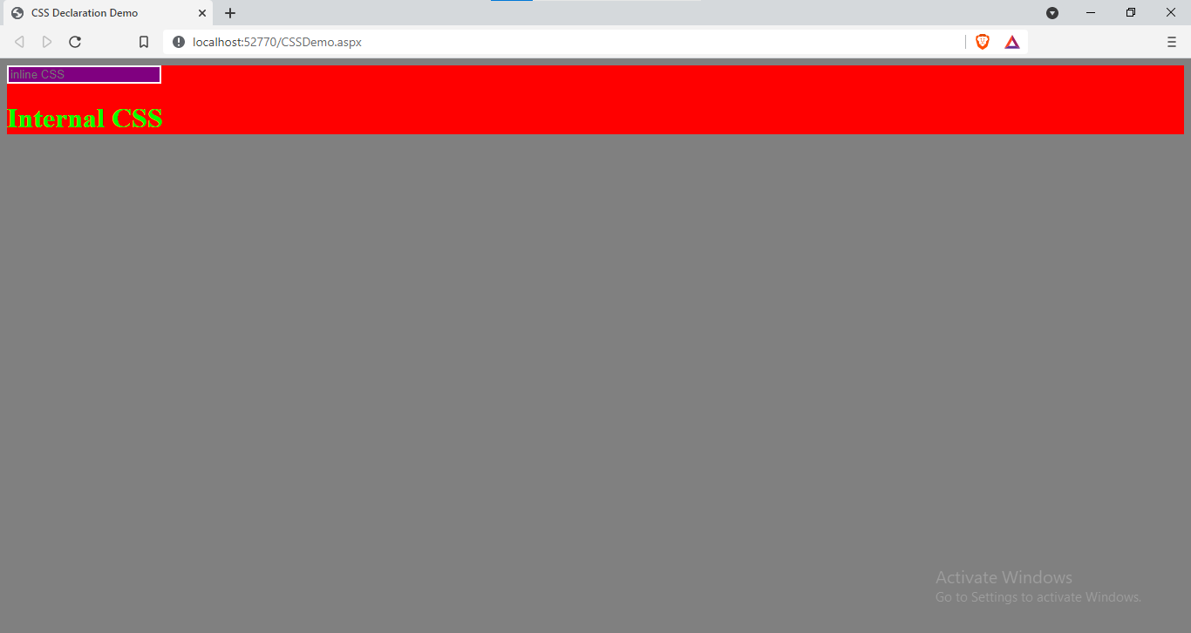

|  |  |  |  |
| --- | --- | --- | --- |
| Start Date | End/Sign Date | Faculty Sign | Remarks/Grade |
|  |  |  |  |

Practical – 8

## Aim : Create a web page using the concept of Theme & Skin in ASP.NET.

ThemeAndSkin.aspx

<%@ Page Theme="MyTheme" Language="vb" AutoEventWireup="false" CodeBehind="ThemeAndSkin.aspx.vb" Inherits="Practical_08.ThemeAndSkin" %>

<!DOCTYPE html PUBLIC "-//W3C//DTD XHTML 1.0 Transitional//EN" "http://www.w3.org/TR/xhtml1/DTD/xhtml1-transitional.dtd">

<html xmlns="http://www.w3.org/1999/xhtml">

<head runat="server">

<title></title>

</head>

<body>

<form id="form1" runat="server">

<p>

<asp:TextBox ID="TextBox1" runat="server"></asp:TextBox>

</p>

<p>

<asp:TextBox ID="TextBox2" runat="server"></asp:TextBox>

</p>

<asp:RadioButton ID="RadioButton1" GroupName="bool" runat="server" Text="Yes" />

<asp:RadioButton ID="RadioButton2" GroupName="bool" runat="server" Text="No" />

<br />

<asp:Button ID="Button1" runat="server" Text="Button" />

</form>

</body>

</html>

Controls.skin

<asp:TextBox runat="server" BackColor="Black" ForeColor="White" />

<asp:RadioButton runat="server" ForeColor="Purple" />

<asp:Button runat="server" BackColor="Black" ForeColor="Cyan" />

Output:

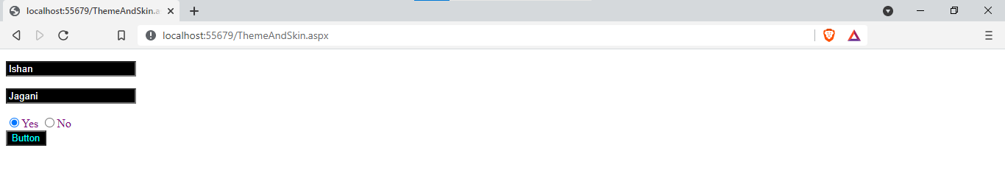

|  |  |  |  |
| --- | --- | --- | --- |
| Start Date | End/Sign Date | Faculty Sign | Remarks/Grade |
|  |  |  |  |